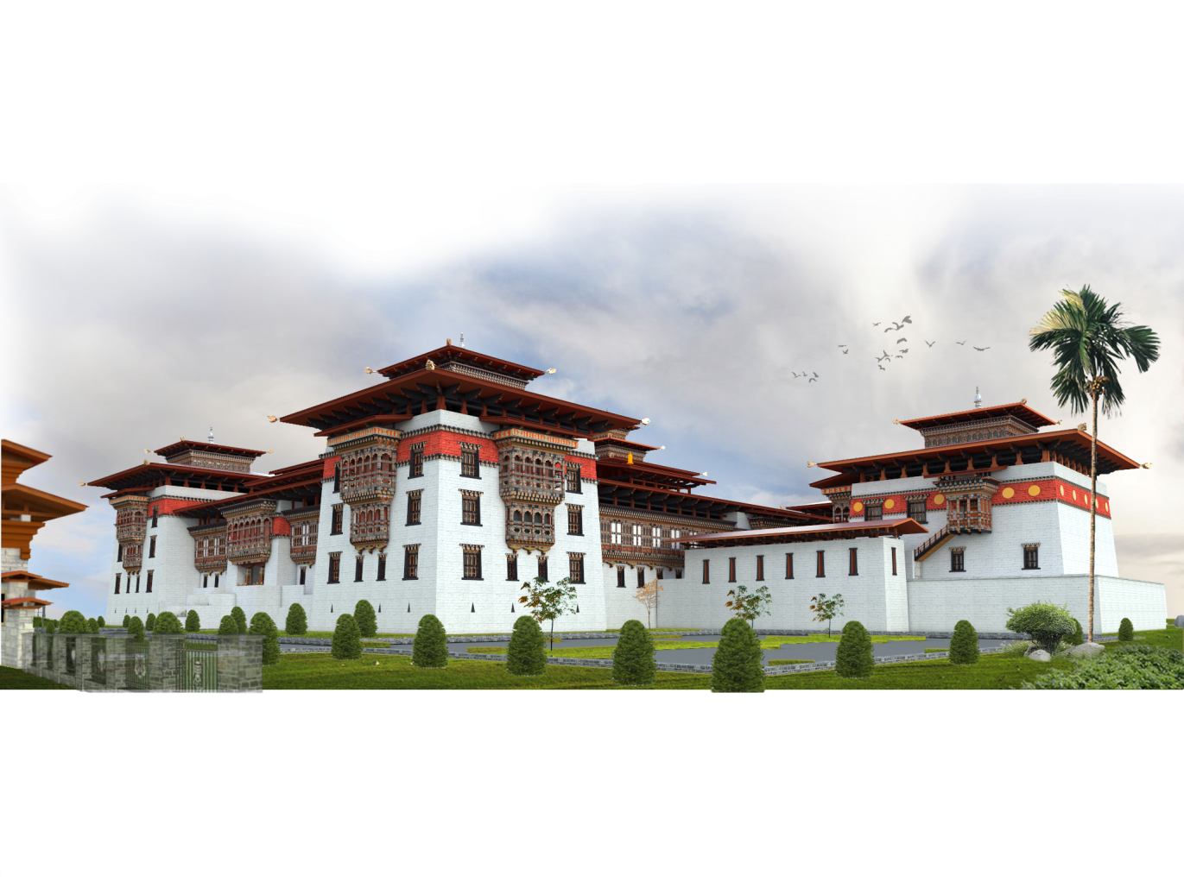

SARPANG DZONGKHAG

24th January 2018

Contents

Background of the Dzongkhag: 3

Back ground of the RNR Expo-Cultural Exchange: 3

Objectives of the Festival/Program: 4

Encourage farmers for commercial production 4

Develop Market linkages for the products 4

Enhance income generation & self-employment 4

Household level food self-sufficiency and Import substitution 4

Promote Cultural program 5

Local Food Products 5

Main Target Groups of the Festival /Program: 5

Main Events of the Festival/Program: 5

RNR Products for the Festival/Program. 6

List of Livestock Products that will be at display for sale: 6

List of Forestry Products/NWFP 6

List of Agriculture Products 6

Cultural Programs 7

Display of the Unique Food Items 7

Sporting Events 7

42KM Marathon between Sarpang-Gelephu 8

Cycling race (about 80KMs within Sarpang) 8

Expected benefit (Outcome/Impact) of the Festival/Program 8

Self-Employment among young people 8

Develop direct deal between Seller & Buyer 8

Create a platform engage all stakeholders 9

Immediate Disposal of the products 9

Exposure for farmers 9

Cost Estimates & Activities for the Festival/Program 9

Conclusion: 10

# Background of the Dzongkhag:

Sarpang *Dzongkhag* is situated in the south-central part of the country and shares its 200 kilometers southern border with the Indian state of Assam, to its east is Zhemgang *Dzongkhag*, to west lies Tsirang and to its north Trongsa *Dzongkhag*. Around three quarters of its land is under forest cover mostly consisting of the broad leaf sub-tropical evergreen trees. The *Dzongkhag* is located in the sub­tropical climatic zone, extending from an elevation of 200 meters to 3,600 metres, from the Phibsoo Wildlife Sanctuary in the west to the Manas National Park in the east.

The *Dzongkhag* has 12 Gewogs namely Gelephu, Samtenling, Sershong, Chuzagang, Umling, Tareythang, Jigmecholing, Gakidling, Dekiling, Sengye, Chhuzergang and Shompangkha, and also one Drungkhag and one Thromde A in Gelephu.

# Back ground of the RNR Expo-Cultural Exchange:

Boosting local economy to achieve the mandates of the Government to become Self-Reliant by 2020 has been the priority of the Dzongkhag in the 10th FYP and 11th FYP which shall continue into the 12th FYP through its strategies and plans and programs.

Dzongkhag has lots of products being produced with many value addition aspects; however, we still face challenges in reaching out our products into the real market. We still face the challenges of not having platform to challenge in the real market in the country although our products have high potential to capture some of the potential markets in the country.

# Objectives of the Festival/Program:

## Encourage farmers for commercial production

With the successful implementation of the expo, it’s expected to encourage our farmers in the villages to go for commercial production rather than for self-consumption. The expo would open opportunities to market their products and earn income at the very minimal cost of transportation and marketing procedures.

## Develop Market linkages for the products

The expo is expected to explore different market linkages within the country and it’s expected to explore for direct contact system between the farmers and buyers around the country which in long run would solve the problem of marketing the local products without having to engage the middle men in selling the products.

## Enhance income generation & self-employment

Our main aim is to provide platform to engage our farmers for mass production and enhance their income generation opportunities within the community which would also help in creating self-employment in the Dzongkhag.

## Household level food self-sufficiency and Import substitution

The program is aimed at achieving household level food self-sufficiency and to reduce the import of the RNR products in the Dzongkhag. During the year 2014, the country has spent about Nu. 1787 million on the import of rice and another Nu. 410 million for the import of vegetables. The Country also spent about Nu.1246 million on the import of dairy products during the year 2014 alone. Although, the program may not totally nullify the import, however, it would be a platform to reduce imports and contribute towards the nation building efforts of the Government.

## Promote Cultural program

The cultural program is expected to help in gaining exposure for the local community and it’s expected to provide platform for the visitors to experience different cultural aspects of the Dzongkhag.

## Local Food Products

The visitors will also have the opportunity to experience the real taste of the local food products of the Dzongkhag.

# Main Target Groups of the Festival /Program:

The program is expected to focus mainly on the following target groups that have high potential in making the event successful and in fulfilling the main objectives of the program.

* Farmers in the Dzongkhag
* Local Business and Residents of the Dzongkhag
* Business & High end Hotels & Resorts in the Country
* Dealers of the RNR products in the Country
* Counterpart officials and their local resident population of the neighboring state of Assam.
* Civil servants in the Dzongkhag
* Other farmers in the Country

# Main Events of the Festival/Program:

There would mainly 4 broad programs during the event that shall fulfill the main objectives as mentioned above and these three main events would be the focus during the event in the Dzongkhag.

# RNR Products for the Festival/Program.

There will full display of all the RNR products that are produced locally with excellent packaging and value addition for the products. The products shall be gathered from all the 12 Gewogs in the Dzongkhag based on their availability and quality of the products.

The list of the RNR products are as mentioned below and it would be available at a very reasonable prices.

## List of Livestock Products that will be at display for sale:

|  |  |  |
| --- | --- | --- |
| SlNo | Details of the product | Remarks |
| 1 | Yogurt | 300 Cups |
| 2 | Cheese | 800 Numbers |
| 3 | Butter | 400 Kgs |
| 4 | Table Eggs | 100 Cartoons |
| 5 | Fresh Chicken | 200 Kgs |
| 6 | Fresh Pork | 200 Kgs |
| 7 | Sikkam | 150 Kgs |
| 8 | Smoked Fish | 200 Pkts |
| 9 | Local Wet Fish | 150 Pkts |
| 10 | Honey | 300 bottles (250ML) |
| 11 | Organic fertilizers | 250 Pkts |

## List of Forestry Products/NWFP

|  |  |  |
| --- | --- | --- |
| SlNo | Details of the Product | Remarks |
| 1 | Bamboo pickles | 100 bottles |
| 2 | Broom stick | 200 numbers |
| 3 | Patsha/Damru | 500 numbers |

## List of Agriculture Products

|  |  |  |
| --- | --- | --- |
| SlNo | Details of the Product | Remarks |
| 1 | Fresh Vegetable |  |
| 2 | Local Rice |  |
| 3 | Kharang |  |
| 4 | Ginger Powder |  |
| 5 | Local Coffee |  |
| 6 | Local Pickle |  |
| 7 | Fresh Fruits |  |
| 8 | Ginger Pickle |  |
| 9 | Candy (banana, Pineapple) |  |
| 10 | Flours (Buckwheat, Millet, Wheat, Maize) |  |
| 11 | Flori-culture |  |
| 12 | Bio-compost & Bio-fertlizer |  |
| 13 | Drolay Pickles |  |

# Cultural Programs

There will be full display of all the unique cultural programs and it shall be performed live during the event. The programs shall be organized keeping in mind the uniqueness of the cultural events from all the 12 Gewogs in the Dzongkhag.

# Display of the Unique Food Items

As part of the event, there will be full display of different unique food items that are part of the life of the people of the Dzongkhag. It would be an event to celebrate with different food items and that can be made available for future orders.

# Sporting Events

Different sporting events will also be organized both for audience and the participant with very attractive prices. The event would be with full of displays and entertainment programs.

## 42KM Marathon between Sarpang-Gelephu

This Marathon would be conducted with the range of 42KM and the runners would carry important messages related healthy living and in general it would also help to spread out messages on the importance of keeping the area neat and clean, the importance on preserving tigers, messages on maintaining clean environment & other messages on different health issues in the Dzongkhag.

## Cycling race (about 80KMs within Sarpang)

The event would also organize open cycling race covering about 80KMs within the Dzongkhag that would also carry the same messages and that would help in spreading messages among the rural communities that in long run would help to instill the sense of belongingness and care for the society at large.

# Expected benefit (Outcome/Impact) of the Festival/Program

With the conclusion of the event, the following are some of the expected outcomes of the even.

## Self-Employment among young people

Experiencing the potentials of the Agriculture and Livestock farming, young people are expected to form groups and carry out commercial farming that would create self-employment.

## Develop direct deal between Seller & Buyer

The program would bring direct link between the seller and the buyer where they would avoid engaging middle men in buying & selling of the products that would become faster and cheaper in reaching the markets.

## Create a platform engage all stakeholders

At the end of the event, it’s expected to become a platform where every stakeholder shall play their own role including the sellers and buyers with support from the Government. It would be an annual event and the program shall attract more dealers to engage in this productive business.

## Immediate Disposal of the products

Coinciding with the peak agriculture season, it is expected that the farmers would be in a position to sale off their perishable products in a shorter period of time and earn good income.

## Exposure for farmers

The event is expected to boost the exposure of the farmers and learning through experience, the idea of such event is expected to spread over to other Dzongkhags in near future.

# Cost Estimates & Activities for the Festival/Program

|  |  |  |  |
| --- | --- | --- | --- |
| SlNo | Particulars | Amount(million) | Remarks |
| 1 | Construction of Expo-Sheds (14 Numbers) | 0.2 | Lumpsum |
| 2 | Water Supply | 0.02 | Lumpsum |
| 3 | Electricity Supply | 0.05 | Lumpsum |
| 4 | Cold Storage | 0.3 | Lumpsum |
| 5 | Vegetable crates | 0.15 | Lumpsum |
| 6 | Packaging Materials | O.1 | Lumpsum |
| 7 | Prizes for Sporting events | 0.5 | Lumpsum |
| 8 | Transportation of RNR products | 0.1 | Lumpsum |
| 9 | Expo Banners | 0.05 | Lumpsum |
| 10 | Others (Miscellaneous) | 0.10 | Lumpsum |
| Total Cost | | **1.47 Million** |  |

# Conclusion:

This event would bring together all the farm products and it shall develop market linkages which will be facilitated by engaging seller and buyer forum. It would boost the morale of the farmers towards going for commercial production with the development of viable markets within the country. This would also help to create self-employment and income generation that in turn would help in attaining food and vegetable self-sufficiency in the Dzongkhag.

The forum/event shall be held on annual basis to gain its popularity and to further reach out to the unreached part of the remote Gewogs in the Dzongkhag. It would serve as forum to create an enabling environment both for sellers and buyers and enhance reaching out to the markets at cheaper cost.

**…………………………………END……………………………………**